

Canyon Grove Academy

REQUEST FOR PROPOSAL

REQUEST FOR PROPOSAL
FOR THE CONSTRUCTION OF A

588 W 3300 N
Pleasant Grove, UT 84062

July 17, 2025

Canyon Grove Academy (hereafter “Canyon Grove”) is requesting proposals for the construction of a new facility. Canyon Grove is building an additional campus in Utah County, Ut. The new facility will be 2 stories, and will be about 30,000 sq ft. The school currently has a piece of property under contract, that is approximately 1.5 acres in size. A conceptual floor plan of the school is attached within the RFP.

The purpose of this RFP is to solicit sufficient information regarding this project so that the School may accurately evaluate the proposals received. This RFP contains sufficient detail regarding the project. Any questions concerning this project should be directed to:

Jeff Biesinger
Canyon Grove Academy
Office: 801-690-1899
Email: jeff@redapplefinance.com

*No other members of the school should be contacted concerning this RFP during the selection process. Failure to comply with this requirement may result in disqualification.

An electronic copy of the proposal shall be submitted to Jeff Biesinger @ jeff@redapplefinance.com

Bids are due no later than 3:00 pm MST Friday, August 8, 2025. Proposals must be signed by an official of the company. Proposals submitted after this deadline will be rejected.

Upon review by Canyon Grove, the firm best meeting the needs of the project team will be awarded the contract to design the new facility. The award will be based equally on fees as well as relevant experience. Canyon Grove reserves the right to accept or reject any or all proposals or any part of any proposal if it is deemed to be in the best interest of the School to do so.

If it becomes necessary to revise this RFP in whole or in part, an addendum will be provided to all bidders who received the original RFP.

Request for Proposal for Construction Services
Canyon Grove Academy

I. Project Description

- Canyon Grove has contracted with Silverpeak Engineering. This is a conceptual drawing of what the school would like to construct. This is not final, and will more than likely change. However, for the purposes of the RFP, please use this as a base line.
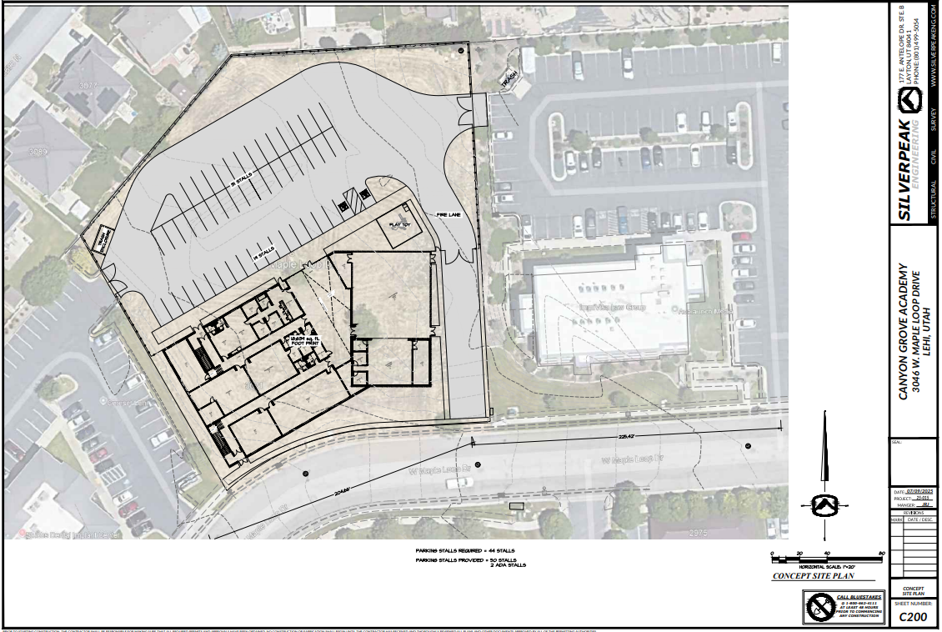
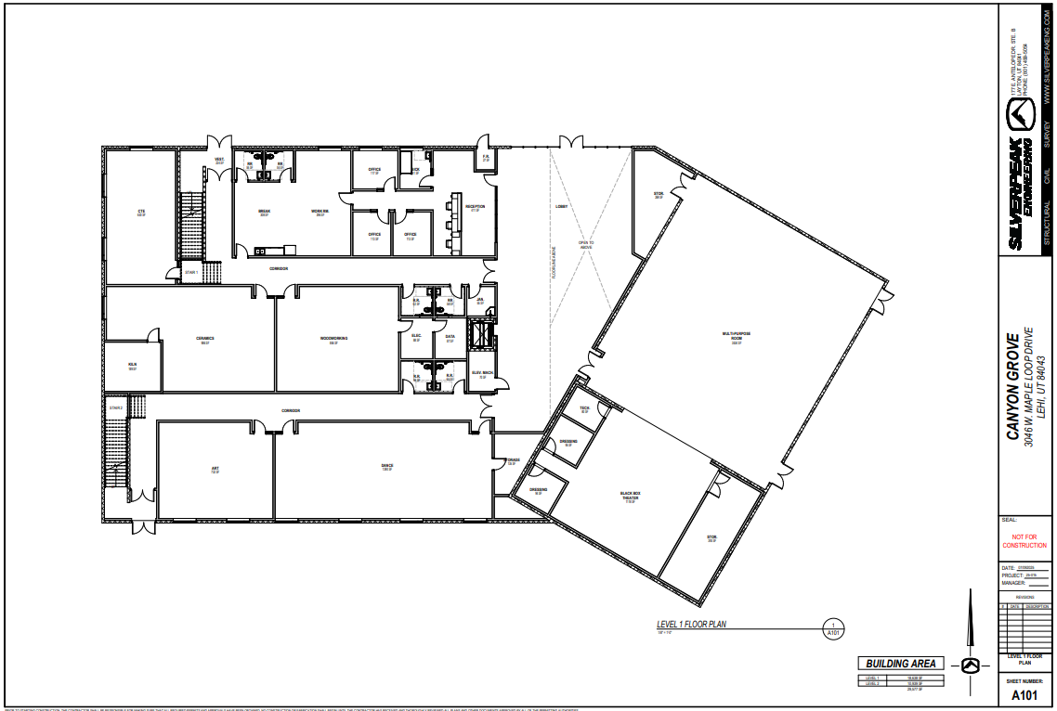
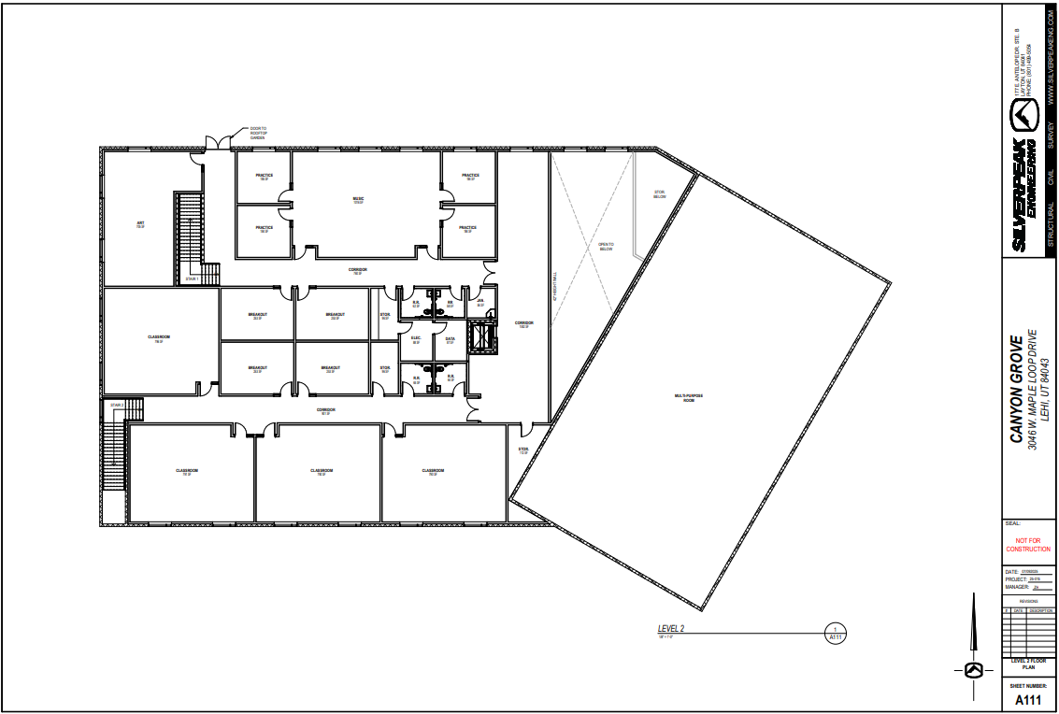

II. Schedule

- July 17, 2025 RFP Released and advertised
- August 8, 2025 Responses due no later than 3:00 PM MT
- August 21, 2025 Final selection and approval
- August 25, 2025 Begin working with the design team

This facility is dependent upon the school receiving financing. Canyon Grove has hired a Financial Advisor, to help guide the school through this process. Before closing on the financing, the school must have a GMP in place.

III. Evaluation Criteria

Please note that the Contractor should submit two separate documents. The first document should be the narrative portion of the RFP, and the second document should be the cost proposal. Failure to submit them separately could result in a disqualification from consideration.

Criteria Unrelated to Cost

- Experience and qualifications of offeror, as it pertains to charter schools (20 pts)
- Ability to meet the requirements of the RFP (10 pts)

Criteria Related to Cost

- The criteria in this section is based on price range. The school understands that final pricing will happen after the school and architect narrows down the specifics of the project. Nonetheless, please provide a price range, which would reflect the initial scope of services, outlined in this RFP. (20 pts)

*Note: Total points available based on Evaluation Criteria: 50 pts

