Earth and Moon 3rd Grade Science
Standard 1
1. I can describe the appearance of the Earth and the moon.
1.a □ I can describe the shape of Earth and the moon as spherical.
1.b □ I can explain that the sun is the source of light that lights the moon.
1.c □ I can list the differences in the physical appearance of Earth and the moon as viewed from space.
2. I can describe the movement of Earth and the moon and the apparent movement of other bodies through the sky.
2.a □ I can describe the motions of Earth. For example: the rotation [spinning] of Earth on its axis, the revolution [orbit] of Earth around the sun.
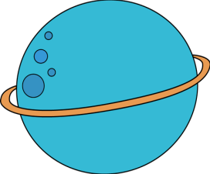
2.b □ I can use a chart to show that the moon orbits Earth approximately every 25
days.
2.c □ I can use a model of Earth
to demonstrate that Earth
rotates on its axis once
every 24 hours to produce
the night and day cycle.
2.d □ I can use a model to
demonstrate why it seems
to a person on Earth that
the sun, planets, and stars
appear to move.
Living vs. Nonliving 3rd Grade Science
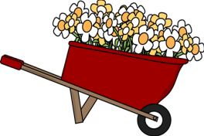
Standard 2
1. I can classify living and
nonliving things in an
1.a □ I can identify characteristics
of living things. For example:
growth, movement,
reproduction.
1.b □ I can identify characteristics
of nonliving things.
1.c □ I can classify living and nonliving things in an environment. 2. I can describe the interactions between living and nonliving things in a small environment.
2.a □ I can identify living and nonliving things in a small environment (e.g. terrarium, aquarium, flowerbed) composed of living and nonliving things.
2.b □ I can predict the effects of changes in the environment (e.g. temperature, light, moisture) on a living organism. 2.c □ I can observe and record the effect of changes (e.g. temperature, amount of water, light) upon the living organisms and nonliving things in a small-scale environment)
2.d □ I can compare a small-scale environment to a larger environment. For example: aquarium to a pond, terrarium to a forest.
2.e □ I can pose a question about the interaction between living and nonliving things in the environment that could be investigated by observation.
Force and Motion 3rd Grade Science

Standard 3
1. I can demonstrate how forces
cause changes in speed or direction
of objects.
1.a □ I can show that objects at rest will not
move unless
a force is applied to them.
1.b □ I can compare the forces of pushing
and puling.
2. I can demonstrate that the greater
the force applied to an object, the
greater the change in speed or direc
2.a □ I can predict and observe what happens when a force is applied to an object (e.g. wind, flowing water). 2.b □ I can compare and chart the relative effects of a force of the same strength on objects of different weight. For example: the breeze from a fan will move a piece of paper but may not move a piece of cardboard.
2.c □ I can compare the relative effects of forces of different strengths on an object. For example: strong wind affects an object differently than a breeze.
2.d □ I can conduct a simple investigation to show what happens when objects of various weights collide with one another (e.g. marbles, balls)
2.e □ I can show how these concepts apply to various activities (e.g. batting a ball, kicking a ball, hitting a golf ball with a golf club) in terms of force, motion, speed, direction, and distance (e.g. slow, fast, hit hard, hit soft).
Gravity
3rd Grade Science
Standard 4
1. I can demonstrate that gravity is a force.
1.a □ I can demonstrate that a force is required to overcome gravity.
1.b □ I can use measurement to demonstrate that heavier objects require more force than lighter ones to overcome gravity.
2. I can describe the effects of gravity on the motion of an object.
2.a □ I can compare how the motion of an object rolling up or down a hill changes with the incline of the hill. 2.b □ I can observe, record, and compare the effect of gravity on several objects in motion (e.g. a thrown ball and a dropped ball falling to Earth).
2.c □ I can pose questions about gravity and forces. 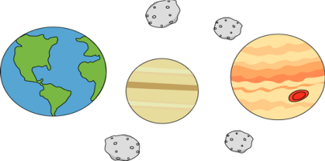

Heat and Light 3rd Grade Science
Standard 5
1. I can provide evidence showing
that the sun is the source of heat
1.a □ I can compare temperatures in sunny
and shady places.
1.b □ I can observe and report how sunlight
affects plant growth.
1.c □ I can provide examples of how sunlight
affects people and animals by providing
heat and light.
1.d □ I can identify and discuss as a class some misconceptions
2. I can demonstrate that mechanical and electrical machines produce heat and sometimes light. 2.a □ I can identify and classify mechanical and electrical sources of heat.
2.b □ I can list examples of mechanical or electrical devices that produce light.
2.c □ I can predict, measure, and graph the temperature changes produced by a variety of mechanical machines and electrical devices while they are operating.
3. I can demonstrate that heat may be produced when objects are rubbed against one another. 3.a □ I can identify several examples of how rubbing one object against another produces heat.
3.b □ I can compare relative differences in the amount of heat given off or force required to move an object over lubricated/non-lubricated surfaces and smooth/rough surfaces. For example: waterslide with and without water.

