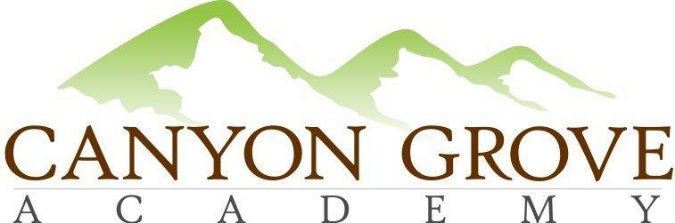

BOARD OF TRUSTEES REGULAR MEETING AGENDA MINUTES

March 30, 2017

1.Call to Order – Members in attendance – Gary Fullmer, Heather Rogers, Patrick Ditty, Linda Bowen, Penny Chinchay; Non-voting members in attendance – Julie Adamic, Sheri Ebert
2. Public Comment Period – no public in attendance
3. Consent Agenda: Approve Meeting minutes from February 2017 – motion Heather, Patrick 2nd – passed unanimously

4. School Administration update
- Academics
- Students & Families
- Operations & Finance
5. Board & Committee updates – PTO update – Penny Chinchay, goals for next year are set, plans set for several future activities; Patrick will be working with administration on a couple of policy updates; Gary proposed cancelling board meeting in April and meeting in May, Thanked Marty for his service on the board, accepted his resignation.

6. Approval: Amendment to 2016-17 School Land Trust plan –motion Linda, Heather 2nd – revised motion “to change the allocated software amount from $11,000 to $1,344 and change the equipment allocated amount from $2,000 to $11,656” revised motion Linda, Heather 2nd – motion carries unanimously

7. Approval: 2017-18 School LAND Trust Plan – Patrick motion, Penny 2nd – passed unanimously
8. (Held discussion at the beginning of the meeting after Public Comment Period) Discussion: Single gender and coed options for Kindergarten – Cyndi Jones & Debbie Wilcox presented concerns regarding classroom dynamics
9. Discussion: Teachers and staff feedback – Gary shared feedback from open office
10. Executive Session: For the purpose of discussing the character, professional competence, or physical or mental health of an individual; discussing pending or reasonably imminent litigation; discussing the purchase, exchange, or lease of real property, discussing the deployment of security personnel, devices, or systems; or investigating allegations of criminal misconduct. Motion for executive session by Heather, 2nd Patrick. Motion to come out of closed session, Linda, Heather 2nd, voted unanimously to end.

11. Action from Executive Session, if any - none
12. Adjournment - Gary motion, Pat 2nd.

