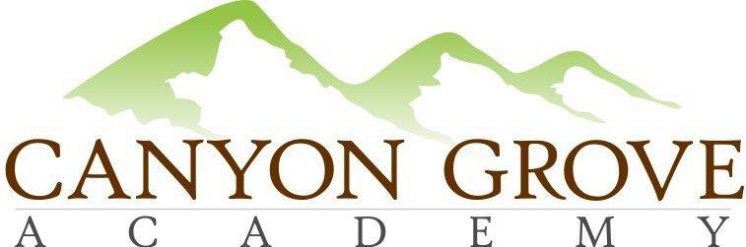

BOARD OF TRUSTEES REGULAR MEETING AGENDA

September 22, 2016

1. Call to Order – Board Members in attendance: Gary Fullmer, Patrick Ditty, Linda Bowen, Mardy Rich; Non-voting members in attendance, Lani Pili and Julie Adamic

2. Public Comment Period – No public in attendance
3. Consent Agenda: Approve Meeting minutes from August 2016 – Mardy motioned, Patrick second

4. School Administration update -great progress, awesome enrollment numbers – currently 592 enrolled total
- Academics
- Students & Families
- Operations & Finance
5. Board Chair and committee update – discussion on Distance Ed communication and FLL, will solicit a distance ed parent to join board
6. Approval: School Calendar Correction - ½ days for Nov 3&4 and March 6&7 – motion to update the school calendar to change Nov 3, 4 March 7 from a full day to half day, Mardy motioned, Linda second, motion carries unanimously

7. Approval: FLL Funding in FY 17 budget – this was determined to not be needed.

8. Executive Session: For the purpose of discussing the character, professional competence, or physical or mental health of an individual; discussing pending or reasonably imminent litigation; discussing the purchase, exchange, or lease of real property, discussing the deployment of security personnel, devices, or systems; or investigating allegations of criminal misconduct.

9. Action from Executive Session, if any
10.Adjournment – Mardy motions, Patrick second

