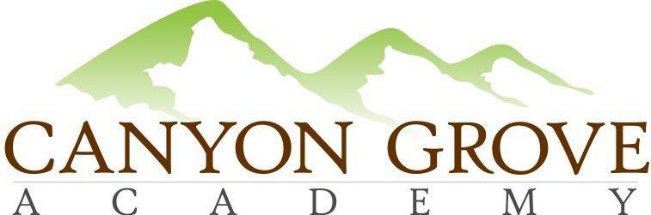

BOARD OF TRUSTEES REGULAR MEETING AGENDA

April 21, 2016 – 6:00 pm

1. Call to Order – Board members in attendance in person – Gary Fullmer, Linda Bowen, Mardy Rich, Heather Rogers, administration in attendance – Sheri Ebert, Julie Adamic - via phone, Lani Pili

2. Public Comment Period
3. Consent Agenda: Approve Meeting minutes from March 2016 – motion Linda, 2nd Mardy – voting unanimous in affirmative
4. Board Chair Update – failed to meet one standard – expenditures 18% below budget, exceeding the 5% allowance

5. School Administration update
- Academics – Distance Ed excitement
- Students & Families – looking at good enrollment for 2016/17
- Operations & Finance – good position for growth

6. Approval: Becky Herzog Parent Representative to Board of Trustees and Parent Committee Chair effective June 1, motion Mardy, 2nd Heather – voting unanimous in affirmative
7. Approval: Admin Goals and Compensation Committee – motion Mardy, 2nd Heather – Gary, chair; Heather, committee member. Review process annually. Mardy made motion to rescind, Heather agreed. Approve a compensation committee with Gary Fullmer as chairperson and Heather Rogers as a committee member setting goals for the administration and defining goals for administrators including compsenation based on goal performance. Motion Mardy, 2nd Heather. Voting unanimous in the affirmative.
8. Executive Session: For the purpose of discussing the character, professional competence, or physical or mental health of an individual; discussing pending or reasonably imminent litigation; discussing the purchase, exchange, or lease of real property, discussing the deployment of security personnel, devices, or systems; or investigating allegations of criminal misconduct.

9. Action from Executive Session, if any
10.Adjournment – motion Heather, 2nd Mardy.

