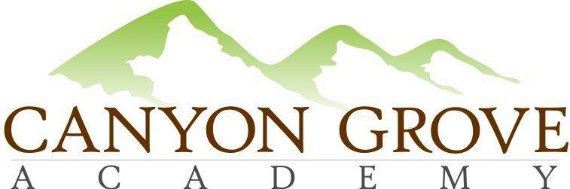

BOARD OF TRUSTEES REGULAR MEETING AGENDA

March 17, 2016 – 6:00 pm

1. Call to Order – Board Members in Attendance: Marty Rich, Gary Fullmer, Linda Bowen, Heather Rogers via phone, Don Fultz via phone; Non-board members in attendance: Sheri Ebert, Julie Adamic, Lani Pili via phone, Kim Goates, Mapu Weiss

2. Public Comment Period – no public in attendance
3. Consent Agenda: Approve Meeting minutes from February 2016 – Linda motion to waive reading, Marty 2nd, voting unanimous in affirmative
4. Update: Kitchen and Garden – 4 chickens – 3rd grade girls take care of as classroom pet, 4x6 area across from garden

5. Board Chair Update – Kelly Rich stepping down from Vice Chair position
6. School Administration update – see the board packet
- Academics
- Students & Families
- Operations & Finance

7. Approval: Policy Committee member changes – Marty Motion to remove Kelly Rich and replace with Gary Fullmer as head of policy committee, Linda 2nd, voting unanimous in affirmative
8. Update: Distance Education Program – Kim Goates – Distance Education Director
9. Update: Parent Rep Election for SY17 – some good possibilities, open up for application for all parents,
10. Executive Session: For the purpose of discussing the character, professional competence, or physical or mental health of an individual; discussing pending or reasonably imminent litigation; discussing the purchase, exchange, or lease of real property, discussing the deployment of security personnel, devices, or systems; or investigating allegations of criminal misconduct.
Motion to move to executive session by Marty, 2nd Linda. Heather motioned to come out of closed session. Linda 2nd.

11. Action from Executive Session, if any – None.
12. Adjournment, Marty motioned, Linda 2nd.

