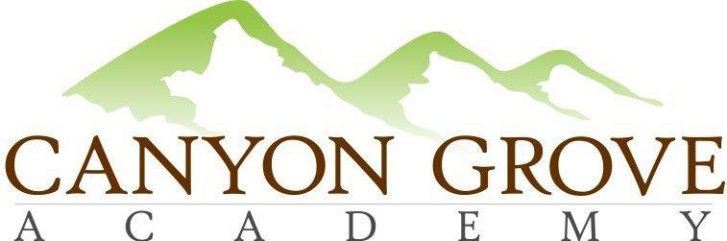

BOARD OF TRUSTEES REGULAR MEETING AGENDA MINUTES

Jan 19, 2017 – 6:00 pm

1. Call to Order – Board Members In attendance, Gary Fullmer, Linda Bowen, Heather Rogers, Penny Chinchay, Patrick Diddy; Non-voting members in attendance, Julie Adamic, Sheri Ebert, Lani Pili

2. Public Comment Period – No public in attendance
3. Consent Agenda: Approve Meeting minutes from Nov 2016, Heather moved, Patrick 2nd, motion carried unanimously
4. School Administration update

5. Board and Committee updates
6. Discussion: evidence-based methods and academics data
7. Executive Session: For the purpose of discussing the character, professional competence, or physical or mental health of an individual; discussing pending or reasonably imminent litigation; discussing the purchase, exchange, or lease of real property, discussing the deployment of security personnel, devices, or systems; or investigating allegations of criminal misconduct.

8. Action from Executive Session, if any
9. Adjournment, Linda motions, Heather 2nd

