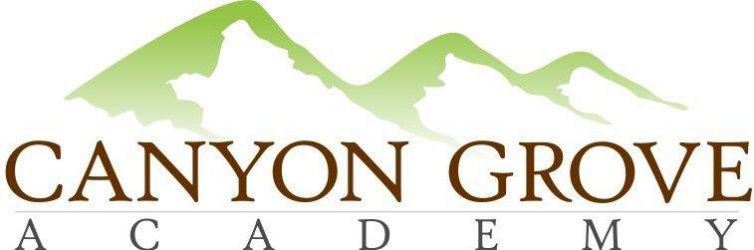

BOARD OF TRUSTEES REGULAR MEETING MINUTES

January 29, 2018, 4:30 pm
https://zoom.us/j/503417281

1. Call to Order – in attendance via zoom; voting board members: Gary Fullmer, Linda Bowen, Worthy Lee, Heather Rogers, Pat Ditty; non-voting board member: Julie Adamic
In attendance onsite (at school) non-voting board member Kim Goates
2. Public Comment Period - none
3. Consent Agenda: Approve Meeting Minutes from Nov 2017 – Worthy motion, Linda second

4. Nomination and Approval: James Ure as Canyon Grove Academy Board of Trustees, President and Chair – Patrick motion, Heather second: Motion to approve James Ure as Canyon Grove Academy Board of Trustees President and Chair, effective 8 am February 1, 2018. Linda motion, Patrick second – motion carries unanimously.
5. Approval: James Ure as Canyon Grove Academy Finance Committee Chair – Heather motion, Patrick 2nd; motion carries unanimously
6. Approval: Patrick Ditty as Canyon Grove Academy Policy Committee Chair – Worthy motion, Linda second; motion carries unanimously
7. School Administration update
8. Board and Committee updates – Julie left at 5:25 during Board update
9. Executive Session: For the purpose of discussing the character, professional competence, or physical or mental health of an individual; discussing pending or reasonably imminent litigation; discussing the purchase, exchange, or lease of real property, discussing the deployment of security personnel, devices, or systems; or investigating allegations of criminal misconduct. None

10. Action from Executive Session, if any None
11. Adjournment – motion Patrick, Heather second

