School Supplies for Mexico
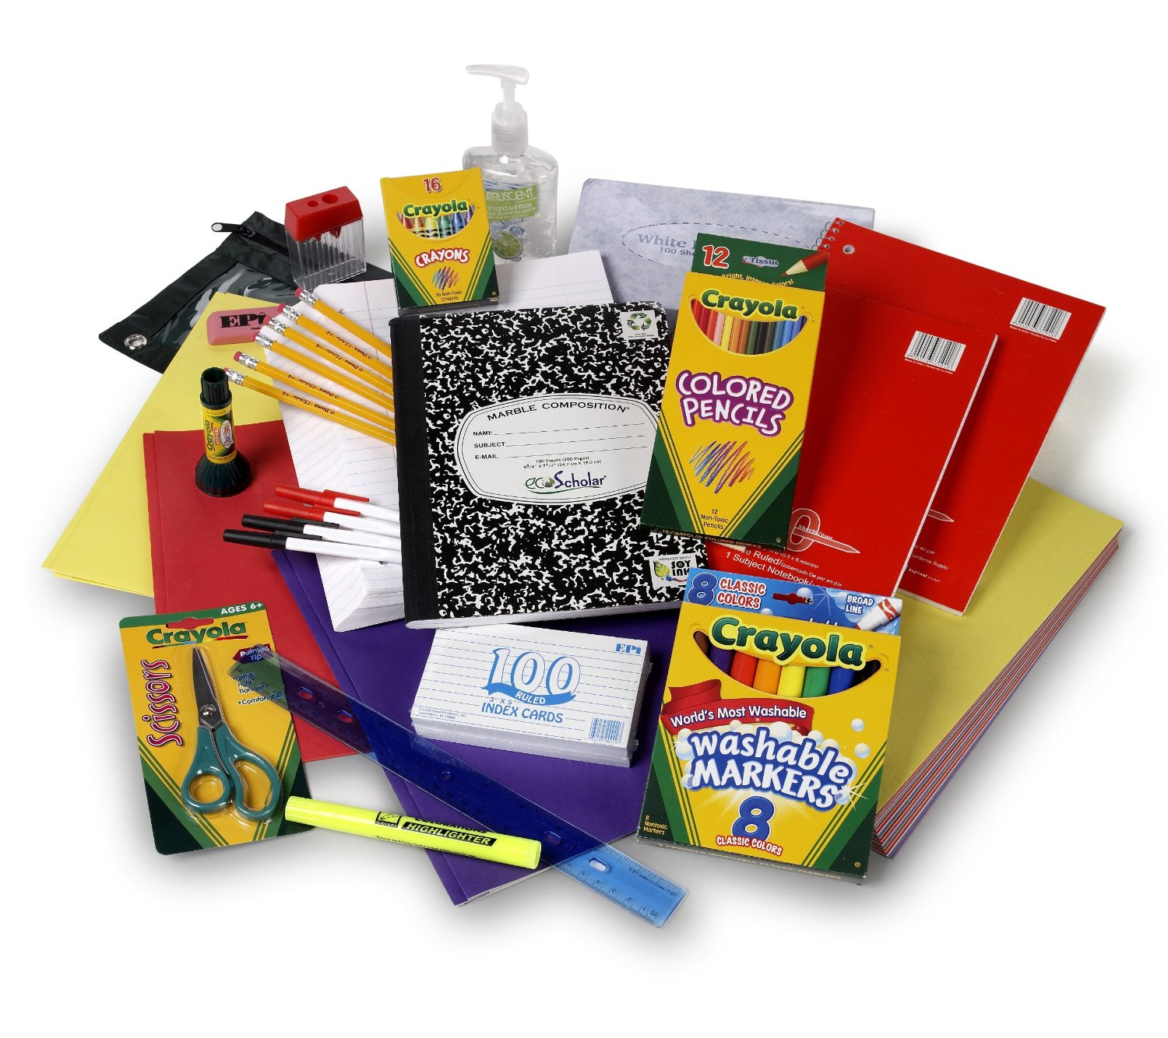
This February our Executive Director will be delivering donated school supplies to Mexico!

Items that are needed include:
Notebooks
Scissors
Glue sticks
Colored pencils
Markers
Highlighters
Rulers
Compasses
Copy paper
Bilingual books,
and other items

Due by 02/08/2019

